Activity 3.1: A report on Moore’s Law
Use the text and images on the following pages of this worksheet to design a two-page report on Moore’s law. The report must explain Moore’s Law to students of your own age.
You do not need to include all of the text and images provided. You can select whatever you think is most relevant and interesting. You can also edit the content and may even carry out your own research to add to it.
Use the grid below to complete stage 1 of the design cycle: understand the task (ask yourself questions about the purpose of your document and its intended audience).

Purpose | What does the report need to do?  What information does it need to give to the person reading it and how should the information be presented to make it accessible to the audience?
Audience | Who is the report for?  What will the intended audience find attractive and enticing?

Then move on to stage 2 of the design cycle: develop your ideas and plan a solution.
And, when you have planned your report, move on to stage 3 of the design cycle: follow your plan to create your solution.
Remember to save your work regularly.

The first computers, such as ENIAC, took up so much space that they filled large rooms. Yet their processing power was tiny when compared with a modern computer.
The first big reduction in the size of electronic computers came when the large valves that processed data were replaced by much smaller transistors. The next big reduction in size came in 1959 when Jack Kilby and Robert Noyce invented the microchip.
Invented in the late 1940s, the transistor reduced the size of computer circuits and, at the same time, brought enormous improvements in reliability. The inventors of the transistor – William Bradford Shockley, John Bardeen and Walter Houser Brattain – were awarded the Nobel Prize in Physics in 1956 for their discovery of the transistor effect.
Gordon Moore was born in 1929. He is an American businessman, engineer and the co-founder and chairman emeritus of Intel Corporation. Moore’s law is named after him.
Moore’s Law refers to Moore’s realisation, in 1975, that the number of transistors on a microchip doubles every two years, so he predicted that the growth in the processing power of the computer would be exponential.
Transistors are small electronic components that act like a switch. They are used to build the gates that process data inside a computer. The more transistors there are, the faster the data can be processed. Computers in the early 1970s had thousands of transistors. Today’s computers have billons of transistors but, due to miniaturisation, their central processing units (CPUs) are more or less the same size as the chips in computers of the early 1970s.
The invention of the microchip by Jack Kilby and Robert Noyce in the late 1950s paved the way for the dramatic reductions in size of CPUs inside a computer. The microchip miniaturised the transistor, making it possible to fit large numbers of transistors into a very small space. The invention of the microchip was probably one of the most important inventions ever made and it launched a new information age.
Moore also pointed out that the cost of a personal computer was not increasing over time and, therefore, the cost of processing power was approximately halved every two years.
Moore did not set out to predict the future and yet his observation of the trend that lies behind the law that is named after him enabled people to predict the processing power and the probable cost of computers in the future. Time has shown that Moore’s predictions were remarkably accurate.
We might expect Moore’s law to continue forever, but that is not physically possible. To fit more and more transistors on a microchip means making the transistors smaller and smaller. At the time of writing, the world’s smallest-ever working transistor is 1 nanometre long. Is it possible to make a smaller transistor or has the minimum size possible now been reached?
As microchips became more powerful, with an increase in the number of transistors built into them, it also became possible to make them smaller. This meant that that computers that depended on them could also become smaller. Computers did indeed shrink!
The end of Moore’s Law? The chip industry has acknowledged that it is no longer economical to reduce the size of silicon transistors further. Instead, microchips look set to change in different ways. The way microchips are designed and integrated into computer circuits has not changed very much over the years and so it should be possible to make improvements in processing speed by redesigning them and changing the way they are integrated without further increasing the number of transistors on the processor.
The next generation of computers will not process data in the same way as our current digital devices. They will use quantum computation. These new generation computers are called quantum computers and they will dramatically increase the speed at which computers of the future will process data.


Gordon Moore
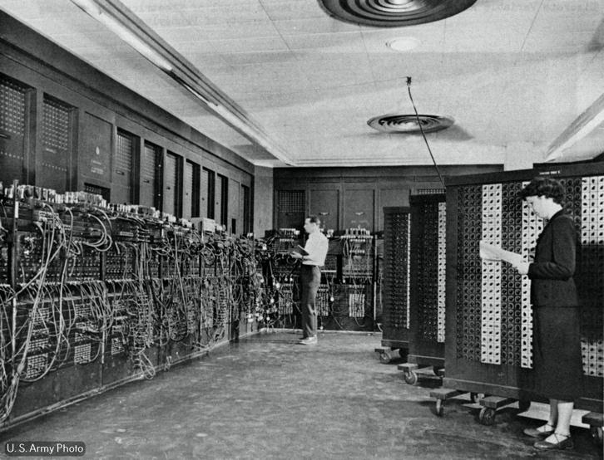
ENIAC

Computer valves
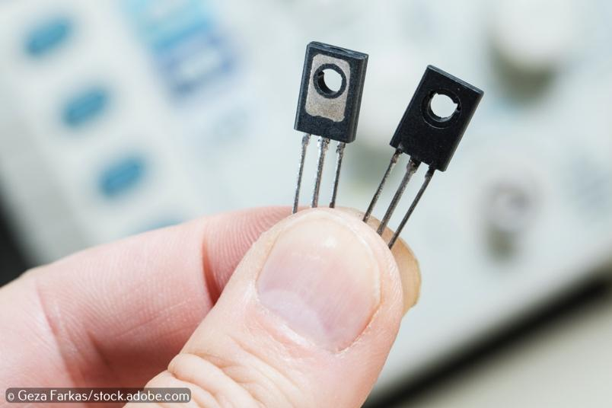
Transistors
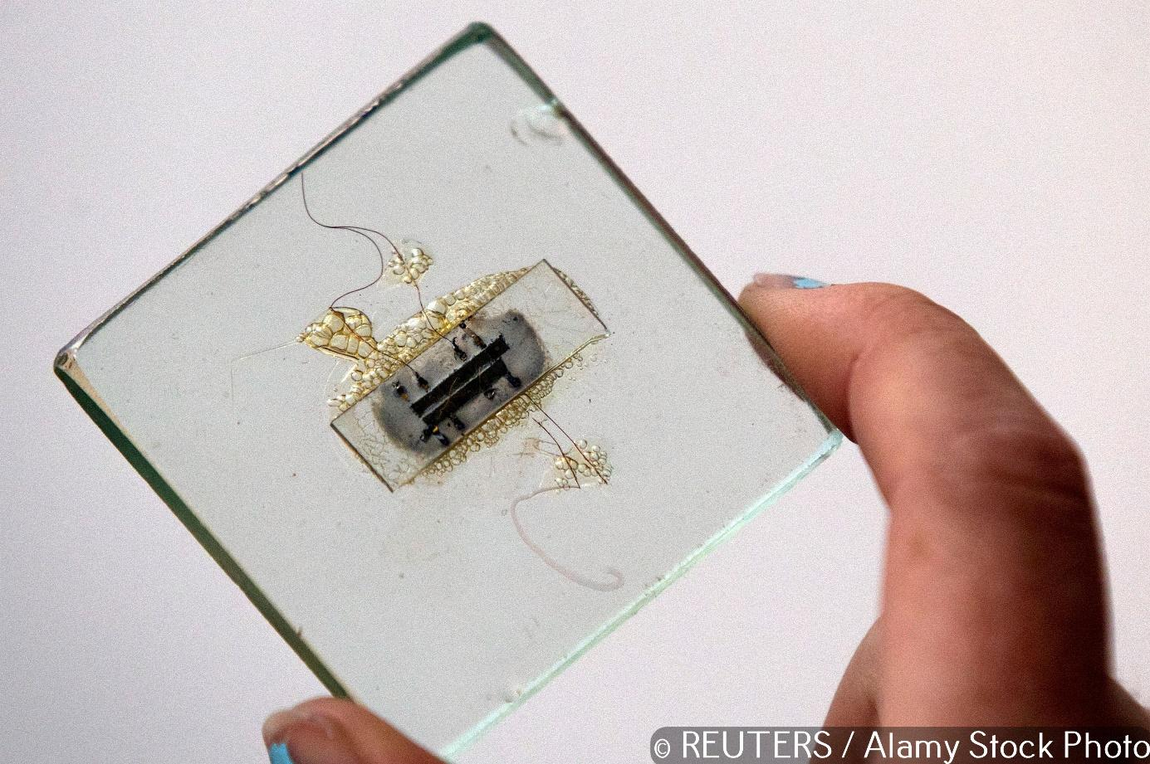
An early microchip

Microchip with several transistors
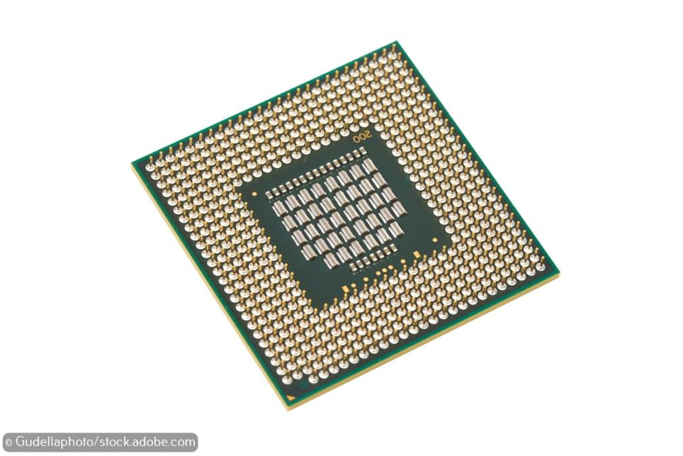
CPU (Central Processing Unit)


Quantum Computer

Processor | Year | Number of transistors
4004 | 1971 | 2250
8008 | 1972 | 2500
8080 | 1974 | 5000
8086 | 1978 | 29,000
286 | 1982 | 120,000
386TM processor | 1985 | 275,000
486 TM processor | 1989 | 1,180,000
Pentium® processor | 1993 | 3,100,000
Pentium® II processor | 1997 | 7,500,000
Pentium® III processor | 1999 | 24,000,000
Pentium® 4 processor | 2000 | 42,000,000
Xeon® processor | 2008 | 1,900,000,000
Number of transistors on a chip (1971 to 2008)

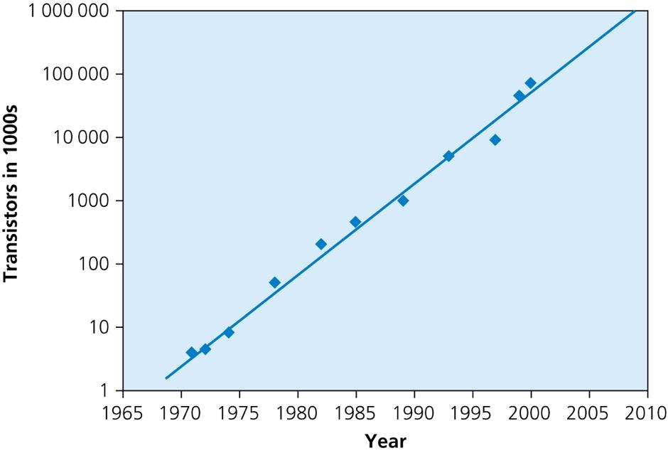
Moore’s Law graph

